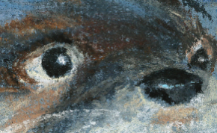
Otter in the Water
Word Search (Ages 4 – 8)

B | C | K | P | O | O | Q | E | S | R | R | T | Y | J | U
E | Y | L | B | Z | B | Y | S | D | T | C | G | A | O | I
N | A | Q | T | L | E | R | C | J | A | L | K | Q | Y | R
Y | D | R | E | P | Y | Q | S | U | S | H | A | R | X | Q
N | L | A | X | W | P | H | M | P | F | M | S | Z | K | O
M | R | I | U | N | K | I | V | R | R | K | A | P | U | A
N | O | G | L | J | B | M | U | Q | L | A | E | M | O | H
A | P | A | P | X | T | Y | Y | I | H | J | Y | Z | O | O
X | B | O | X | O | Y | Q | Z | U | W | H | T | E | F | T
M | A | M | A | H | X | X | D | A | H | Q | R | U | D | T
I | T | J | D | J | V | B | T | Q | S | E | N | P | M | E
J | C | G | E | G | W | E | C | U | H | D | A | O | D | R
H | J | K | V | T | R | O | P | I | L | F | O | R | Q | N
D | S | U | N | K | J | T | N | O | P | N | L | S | T | I
I | F | N | T | P | B | L | R | X | Z | F | I | T | P | I

FUN | HEART | HOME
LEARN | MAMA | MOON
OBEY | OTTER | PAPA
PLAY | PRAYED | SHADE
SUN | WATER
©2020 www.cg3publishing.com

